OLFACTORY GENE COMPARISON

ABSTRACT

Olfactory receptor, also called smell receptor,is a protein capable of binding odour molecules that plays a central role in the sense of smell (olfaction). Olfactory receptors interact with odorant molecules in the nose, to initiate a neuronal response that triggers the perception of a smell. The olfactory receptor proteins are members of a large family of G-protein-coupled receptors (GPCR) arising from single coding-exon genes. Olfactory receptors share a 7-transmembrane domain structure with many neurotransmitter and hormone receptors and are responsible for the recognition and G protein-mediated transduction of odorant signals. The olfactory receptor gene family is the largest in the genome.

**Hypothesis**- As humans have far fewer number of functional olfactory genes than their closest primate relatives. It is assumed that this has contributed to the degeneration of the odour perception in humans. Thus leading to a balancing selection.

METHODS

**Steps for Sequence Retrieval**

1. Firstly, we took the gene id from the research paper and We searched for 8 similar primates.

2. We took their CDNA and CCDS sequences from the NCBI Genbank.

3. If CCDS was not available, we took their protein sequences and reverse translated them to get the CDNA sequences.

4. Next we have aligned the DNA and protein sequences, created their phylogeny and done Tajima D’s test.

The results are as follows:

RESULTS

1. MSA FILE

**- DNA**

**- PROTEIN**

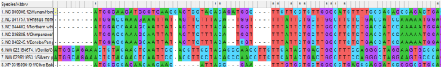

2. PHYLOGENY

- **Neighbour Joining DNA**

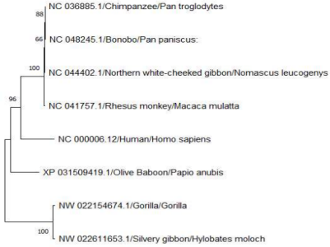

- Maximum Likelihood DN

- **Maximum Likelihood DNA**

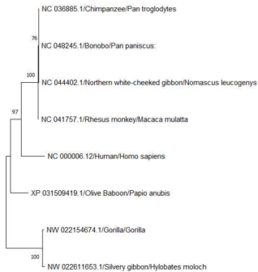

**- Neighbour Joining Protein**

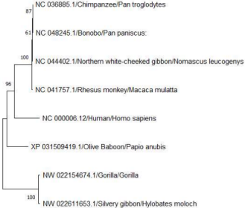

**- Maximum Likelihood Protein**

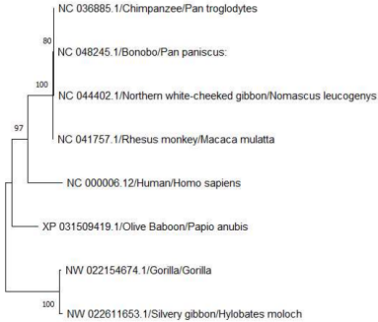

3. TAJIMA’S D with DNA

**Table. Results from Tajima's Neutrality Test [1]**

**m S ps Θ π D**

**8 770 0.786517 0.303340 0.392967 1.624450**

NOTE.-- This analysis involved 8 nucleotide sequences. Codon positions included were 1st+2nd+3rd+Noncoding. All ambiguous positions were removed for each sequence pair (pairwise deletion option). There were a total of 979 positions in the final dataset. Evolutionary analyses were conducted in MEGA11 [2]

Abbreviations: m = number of sequences, n = total number of sites, S = Number of segregating sites, ps = S/n, Θ = ps/a1, π = nucleotide diversity, and D is the Tajima test statistic.

4. No PDB Structure can be found for this gene human structure. Thus further analysis can not be completed.

INTERPRETATION OF RESULTS

PHYLOGENY

A phylogeny is a diagram that depicts the lines of evolutionary descent of different species, organisms, or genes from a common ancestor. Here based on all the trees we can interpret that the olfactory gene of Humans is most related/closest to its ancestor- **NORTHERN WHITE-CHEEKED GIBBON**

TAJIMA’S D

High values of Tajima's D suggest an excess of common variation in a region, which can be consistent with balancing selection, population contraction.

Negative values of Tajima's D, on the other hand, indicate an excess of rare variation, consistent with population growth, or positive selection.

**Here as our D>0 It shows BALANCING SELECTION.**

CONCLUSION

We concluded that Olfactory gene repertoires in primates have evolved in such a way to adapt to their respective living environments. Differential selective constraints might play an important role in the primate olfactory gene evolution in each primate species.

Done by

ANKITA PRADHAN- 21MBD013 ANIKET SARKAR - 21MBD019 KHUSHBU SHARMA-21MBD024 TANISHKA SHAH- 21MBD023